### **Request for Proposal (RFP) for Non-Profit Grant Funding**

#### **Issued By: Food, Animals, & Natural Sustainability (FANS) of the Mid-Willamette Valley Fund**

#### **In Association With: United Way of the Mid-Willamette Valley**

#### **Issue Date: September 30, 2024**

#### **Deadline for Submission: October 25, 2024**

#### **I. Overview**

The Atkinson Graduate School of Management, in association with The United Way of the Mid-Willamette Valley, is pleased to announce a grant opportunity for non-profit organizations in Marion, Polk, and Yamhill counties, working in the fields of animal protection and welfare, natural resource conservation and protection, and food programs. This grant is made possible through funds provided by the United Way of the Mid-Willamette Valley. The goal is to support local organizations that create significant and positive impacts in these areas.

#### **II. Eligibility**

We invite applications for project-based grants from non-profit organizations that:

* Are recognized as a 501(c)(3) entity.
* Operate programs within the Marion, Polk, and Yamhill Counties.
* Are seeking funding for a project in one or more of the following areas:
  + **Animal Protection and Welfare**: Programs that promote the care, protection, and well-being of animals.
  + **Natural Resource Conservation and Protection**: Initiatives aimed at conserving natural resources and promoting sustainable practices.
  + **Food Programs**: Efforts that address food insecurity, nutrition education, and access to healthy food for underserved populations.

#### **III. Grant Amount**

Maximum Total Award: $50,000

Individual Award Range: $5,000-$50,000

The Food, Animals, and Natural Sustainability (FANS) of the Mid-Willamette Valley Fund has a total funding capacity of $50,000, courtesy of the United Way of the Mid-Willamette Valley. We welcome applications ranging from $5,000 up to the full fund amount. Selections will be made in part based on project scope, community impact 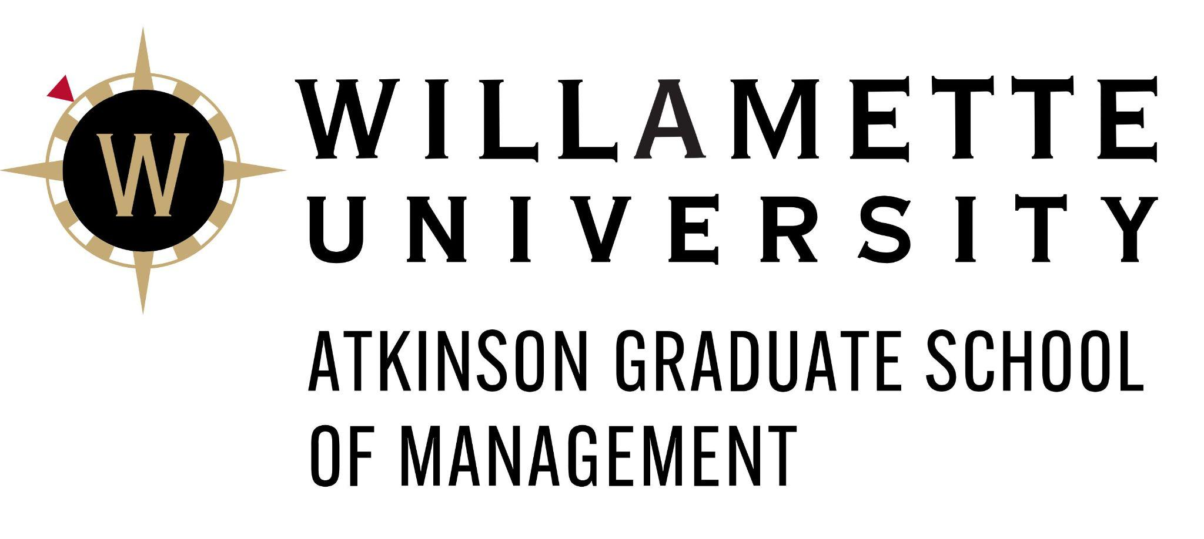potential, and alignment with funding priorities.

#### **IV. Application Guidelines**

To request to apply for this grant, please provide a two-page Letter of Intent (LOI) outlining the following information:

1. **Organization Overview**:
   * Legal Name of Organization and Mission Statement.
   * Address, Website, and Contact Information.
2. **Project Description**:
   * Briefly outline the project or program for which you seek funding.
   * Explain how the project aligns with one or more of the focus areas: animal protection and welfare, natural resource conservation, or food programs.
   * Identify the specific need(s) this project addresses and the community it will benefit.
3. **Goals and Outcomes**:
   * List the primary goals of the project.
   * Describe the expected outcomes and how they will be measured.
4. **Budget**:
   * Briefly describe the funding amount required and explain how it will directly support the described project.

#### **V. Selection Criteria**

Proposals will be evaluated in part based on:

* Alignment with focus areas (animal welfare, conservation, food programs).
* Potential impact on the target community.
* Feasibility and clarity of project scope and goals.
* Measurability of impact and longevity of the project.
* Other relevant factors.

#### **VI. Process Overview**

After the LOI period closes, LOIs will be evaluated based in part on the criteria outlined in Section V. Selection Criteria. Projects that most closely match the goals will be invited to submit a formal, in-depth application which will expand on information provided in the LOI. After application evaluation, members of our team will organize site visits to meet with executive and project leadership from prospective grantees before a final decision is made. The timeline is outlined below:

* **RFP Issued**: 9/30/2024
* **Letter of Intent Deadline**: 10/25/2024
* **Request for Formal Applications**: 11/12/2024
* **Formal Applications Close**: 12/3/2024
* **Site Visits**: 1/28/2024 - 2/25/2024
* **Notification of Award**: 3/13/2024

#### **VII. Submission Instructions**

Please submit your LOI via email to agsm-pici-group@willamette.edu by 10/25/2024. All LOIs must be submitted as a single PDF document and include the name of the non-profit in the filename.

#### **VIII. Contact Information**

For questions or additional information, please email agsm-pici-group@willamette.edu.

